**Write up : Daydreams on sale (final project)**

Synopsis: For the final project, the coffee shop “City shop” was selected, observable on the images below. The manner in which the product is displayed in that window is particularly appealing and stands out among other shops as it is near the middle of the road. Furthermore, the shape and transparency of the vitrine works well for display purposes.

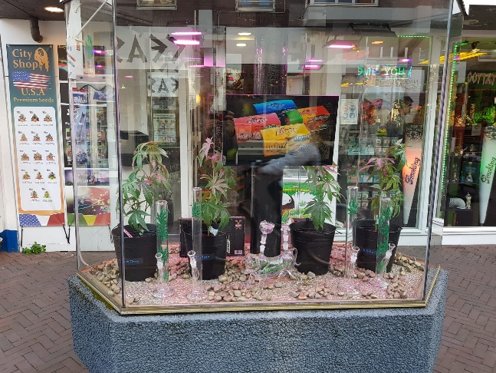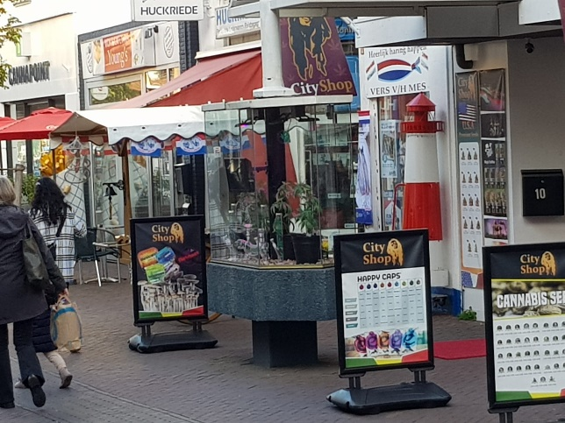Furthermore, the sign right next to the vitrine is also an element that is very employable in a spin-off. Generally, the elements described are all very versatile to different settings, which is something I wish to use in my final project.

Usage:

* Whenever a text box is displayed, the space bar can be pressed to either skip the fill animation or go to the next text. This is the central animation for this game.
* There are sequences in the game where areas can be explored and clicked on with the mouse. When this is done, a prompt with description will appear.
* Note that while a current prompt is active, it is not possible to explore other elements.

Architecture:

* “TextBox” and “dialogue” are the most salient classes, as they are responsible for displaying and presenting the appropriate text at a given time.
* Also important is the “storyProgress”, it is the state machine of this program, meaning that it announces when a new part in the game is breached.
* “ClickArea” sets different areas up which can be clicked to receive an interaction.

ShopAnimation

ImageLoader sets up the image, when “StoryProgress” alters, the background changes. It contains an animation for the shop that is considered part of the background.

Depending on the StoryProgress, different ClickAreas are made available with respect to the background.

When a certain ClickArea is activated, the TextBox is called and the dialogue is altered through “TextCounter”.

The text box is a mechanism that presents the dialogue. An animation plays when it is first displayed, that animation is then reset when the next one is activated.

The TextBoxes are set in an array. When a certain ClickArea is activated, that TextBox is sent for.

TextBox

boolean isActive()

boolean reveal()

Global variable “StoryProgress” is set here.

Main tab

Backgrounds.display()

mainText.display()

ThisStory.resetInteractiveText()

mainText.checkPrompt()

ThisStory.update()

Dialogue:

Texts.display()

Texts.reveal()

ThisStory.textSpawner().clickArea

ImageLoader

ShineAnimation.play()

“Dialogue” decides which text to display, an array with TextBoxes is gone through with a variable called “TextCounter”.

StoryProgress

TextSpawner.make()

ClickArea

“StoryProgress” is the state machine of this program. Depending on which section the story is at, different click areas will be displayed.

This state machine is updated by the “TextCounter”.